1. AIM: Design an automatic night lightning system
2. APPARATUS REQUIRED: a) Arduino uno

b)Breadboard

c)Connecting Wires

d)2 Resistor

e)1 LED

f)LDR

3.CODE:

int sensorPin=A0;

int ledPin=7;

int sensorValue=0;

void setup(){

Serial.begin(9600);

pinMode(7,OUTPUT);

}

void loop(){

sensorValue=analogRead(sensorPin);

Serial.println(sensorValue);

delay(100);

if(sensorValue>300)

{

digitalWrite(7,HIGH);

}

else

{

digitalWrite(7,LOW);

}

}

4:CIRCUIT: 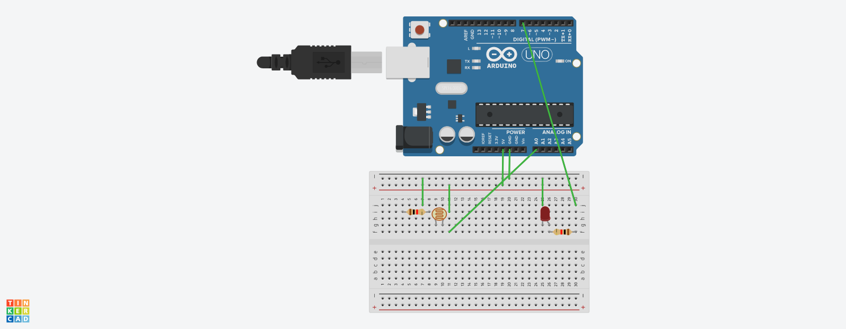

5:RESULT:

Hence the LED automatically turn on when the night starts and automatically turns off in the morning